Taking me as the main subject, my topic is: mirroring.

In the middle of the homepage, I put a picture of me in the mirror. In the mirror, I meant that I was looking at and making this website, and my reflection in the mirror means that someone (the viewer) is at the other end (Looking at me in a virtual network) is like mirroring.

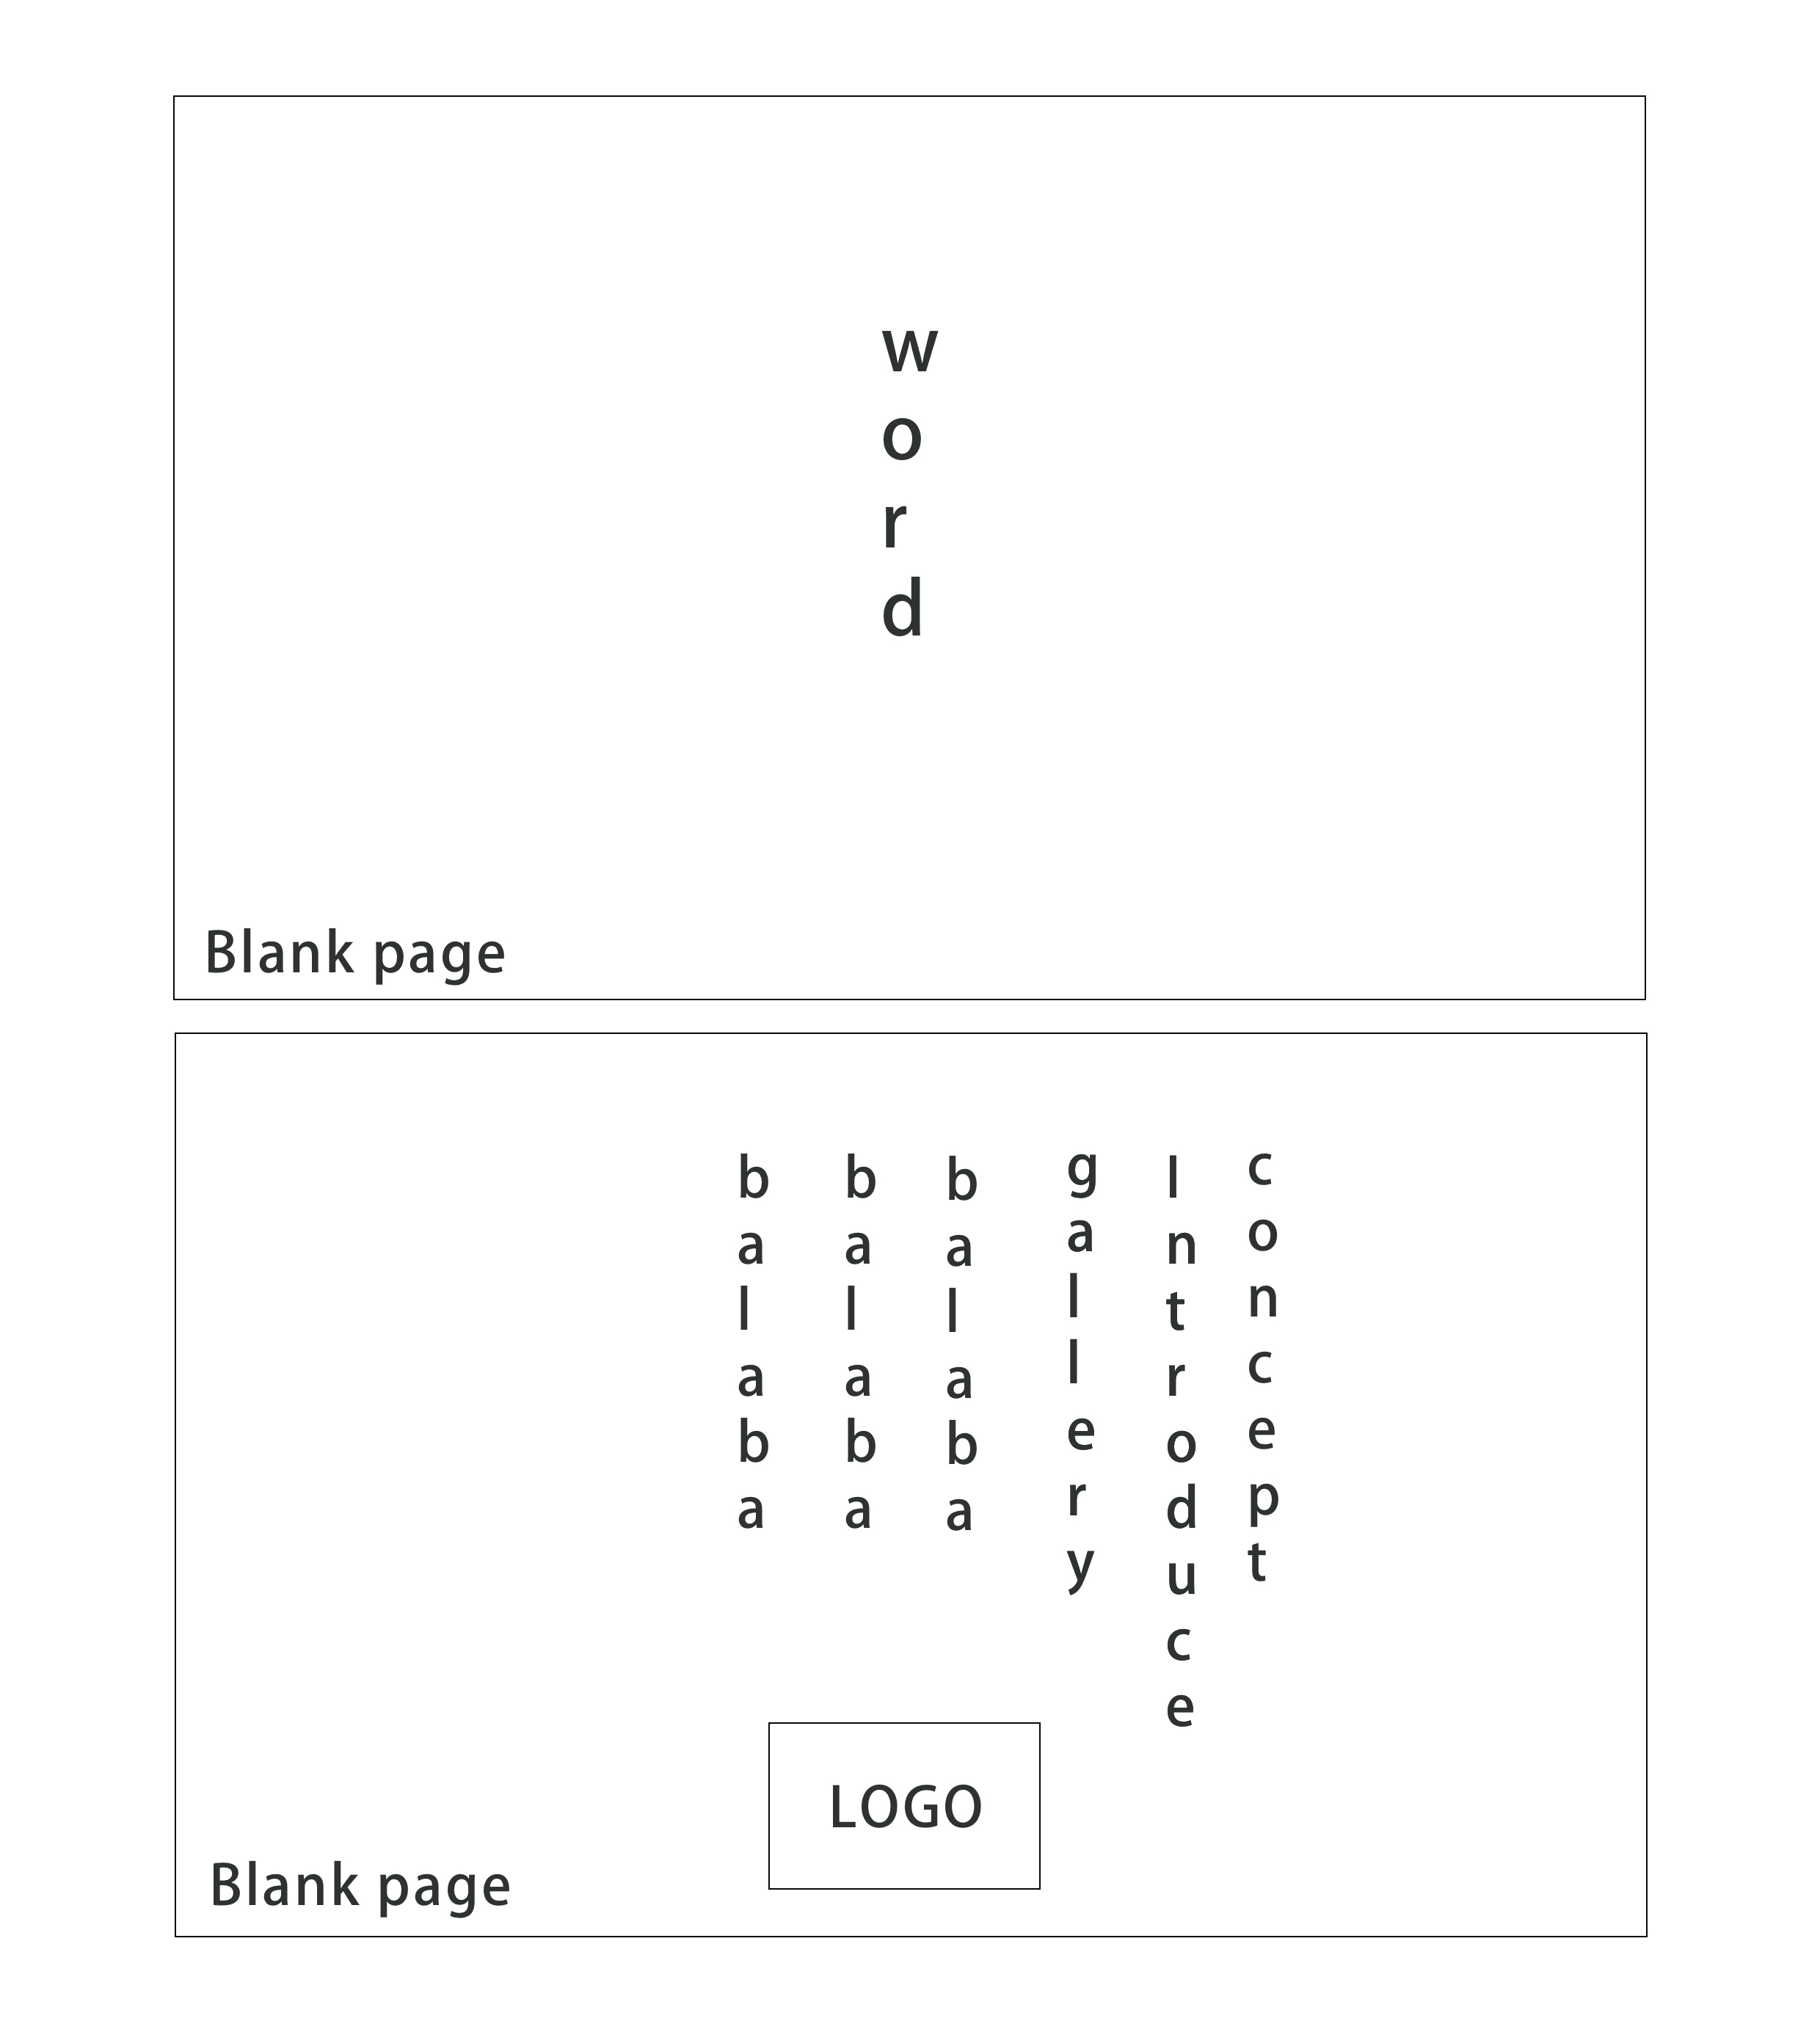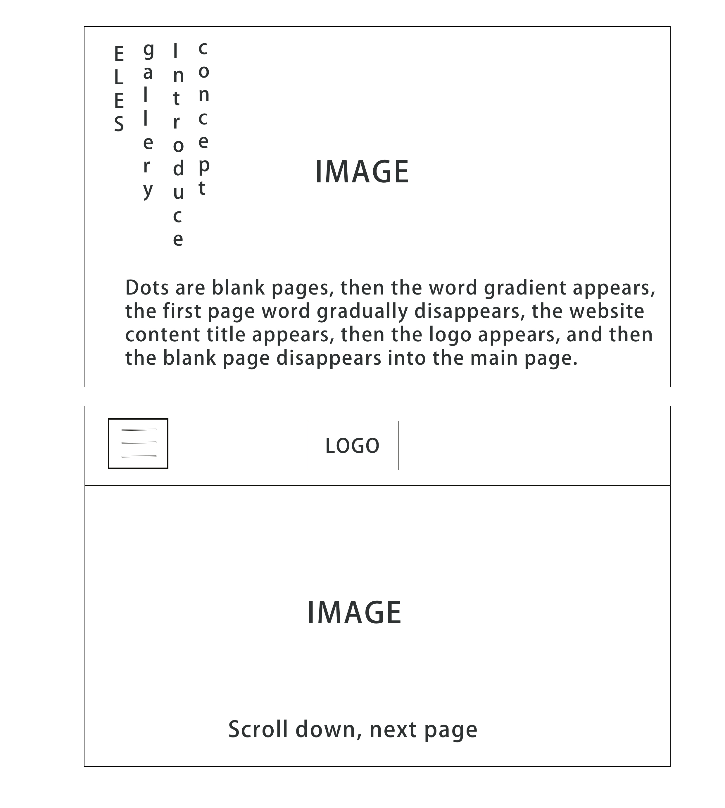

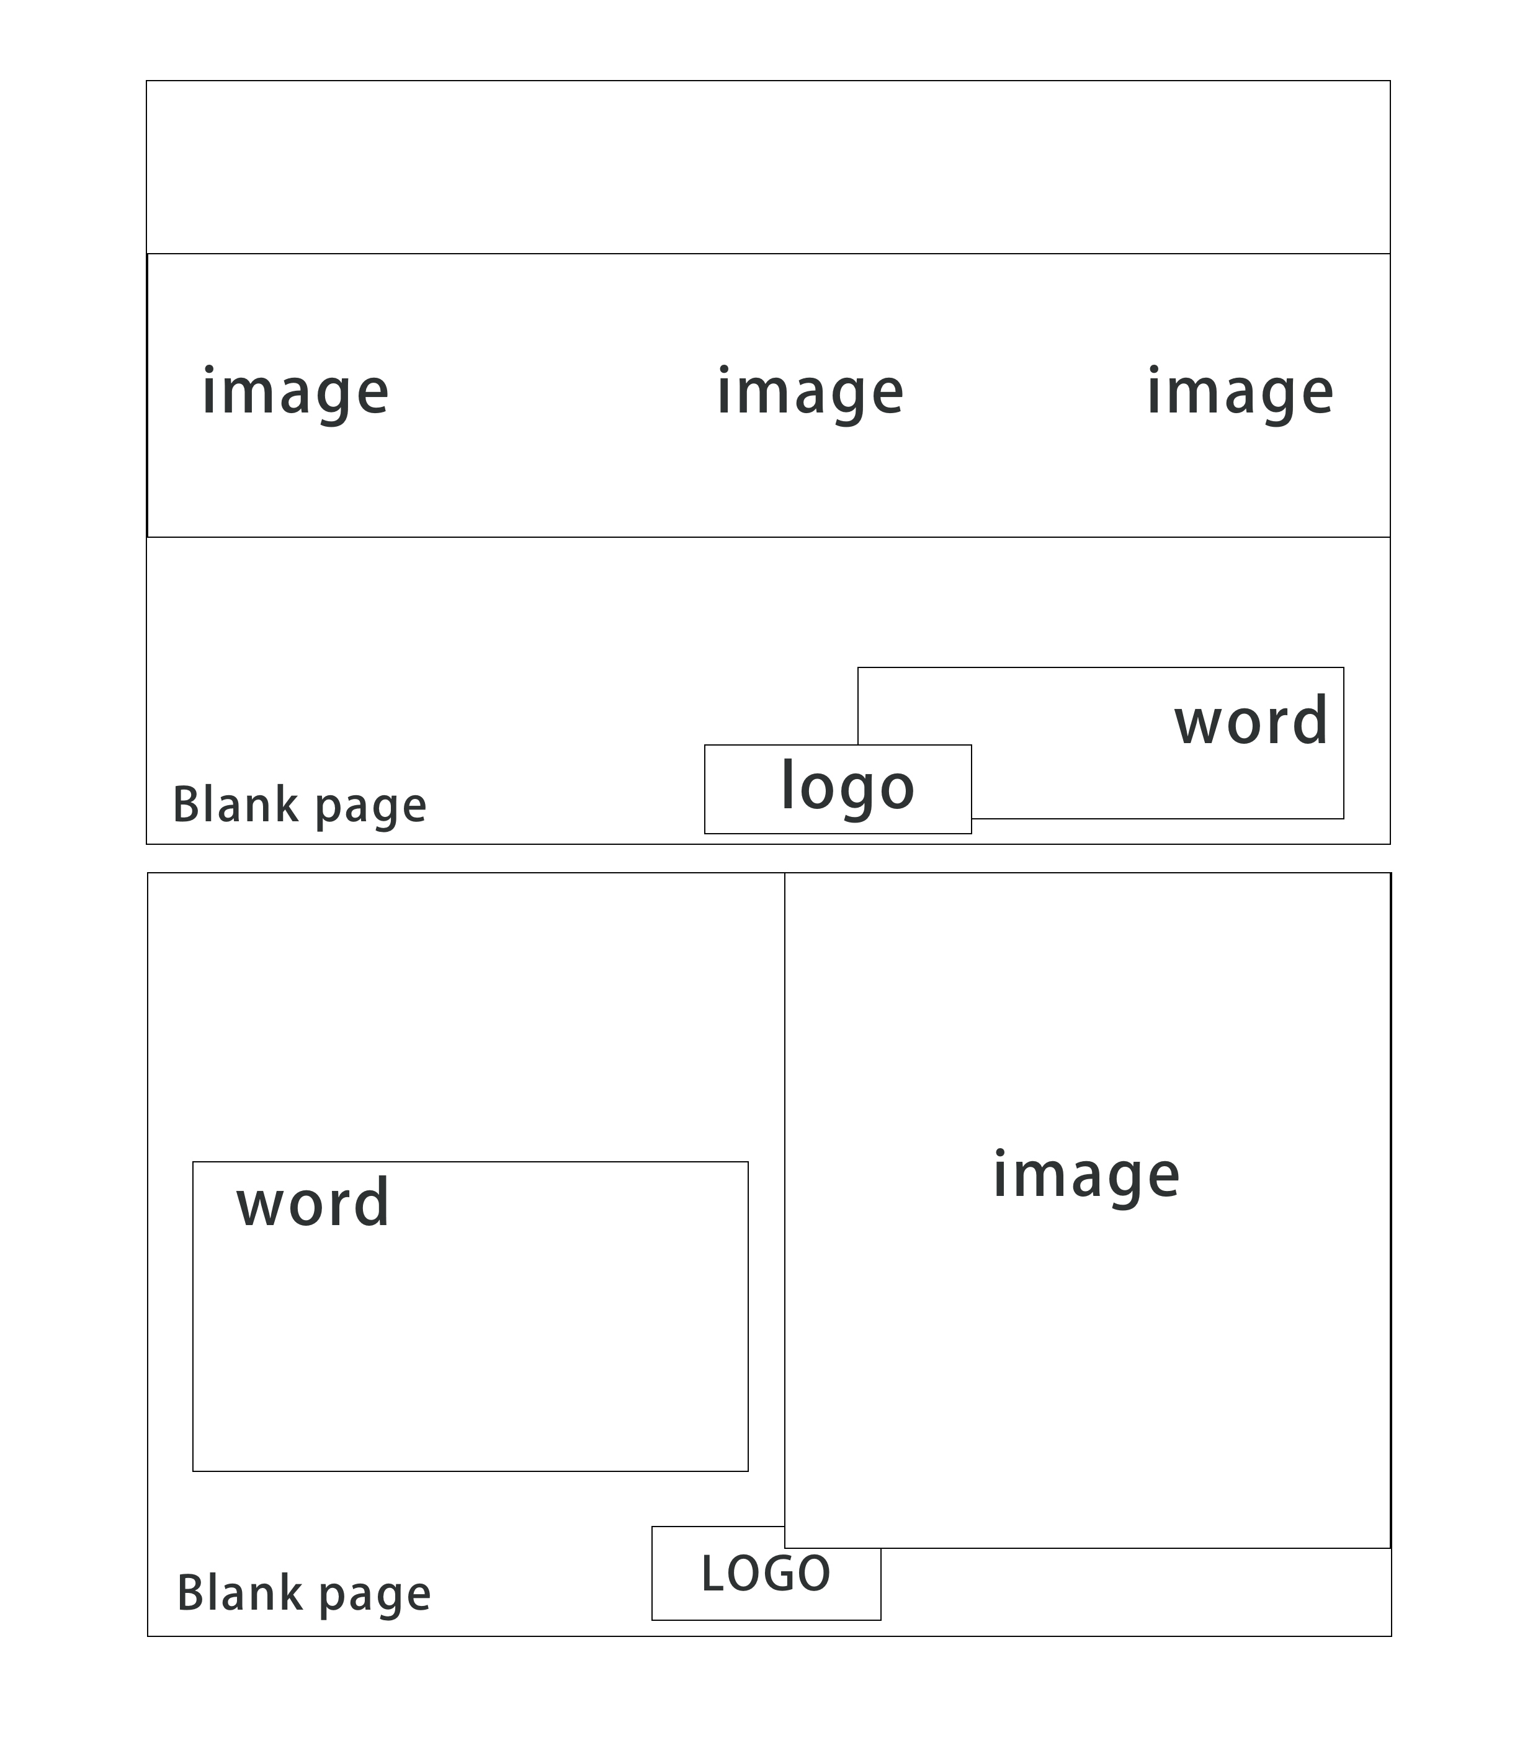

——链接：可以连接到其他的网页作品，有交互性。